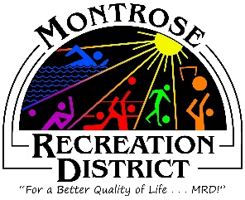

Growth Committee
Thursday, March 28, 2022 at 9:00 am
Montrose Community Recreation Center
16350 Woodgate Road
Montrose CO 81401

Attendees:

- BOLDLY BALDRIDGE (Baldridge Regional Park Master Plan (Rich Neumann, Project Manager, BerryDunn)
  - Overview of scope, timeline, actions
  - Public Engagement
  - Participate in internal stakeholder group activities
  - Questions, Answers, Next Steps

- Define 2024 Statement of Committee Purpose, needs and outcomes

- Montrose Field House Master Plan

- Determine next meeting dates

Next Meetings
Montrose Community Recreation Center
16350 Woodgate Road
Montrose CO 81401

