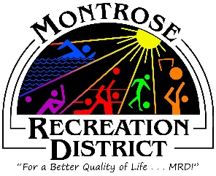

Master Plan Meeting

Growth Committee
Wednesday, June 17, 2021 at 2:00pm
Montrose Community Recreation Center
16350 Woodgate Road
Montrose CO 81401

Attendees:

- Status/Update
  - Progress report of outstanding items
  - Monthly formal report to elected officials
  - Inventory Analysis

- Public Engagement
  - Outcomes from virtual Public Meetings
  - Future engagement;
    - Statistically Valid and Online survey –
    - Intercept surveys
    - Website still open / review comments
    - June 25 The Forum, Montrose Live
    - HAPPiFEET

Next Meetings
Thursday, July 15 at 2pm
Montrose Community Recreation Center
16350 Woodgate Road
Montrose CO 81401
MY NOTES:

