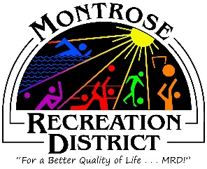

Master Plan Meeting

Growth Committee
Wednesday, May 27, 2021 at 2:00pm
Montrose Community Recreation Center
16350 Woodgate Road
Montrose CO 81401

- Status/Update
  - Progress report of plan to date
  - Monthly formal report to elected officials – will publish following this meeting

- Focus Groups
  - Logistics review
  - Debrief of themes, data collection

- Virtual Public Meetings
  - Logistics review
  - Debrief of themes, data collection

- On ground Site Assessment
  - Logan Simpson

- Public Engagement
  - Future engagement
    - Website: Makemymontrose.com to watch presentation
    - Statistically Valid and Online survey – more comprehensive
    - HAPPiFEET
    - FUNC Fest
      - Intercept surveys – refine questions, determine logistics

- Potential for Citizen Advisory (Super Focus) Group

- MRD Growth Committee – prepare for fall

Next Meetings
Proposed: Thursday May 27 at 2pm
Thursday, June 17 at 2pm
Thursday, July 15 at 2pm
Montrose Community Recreation Center
16350 Woodgate Road
Montrose CO 81401
MY NOTES:

