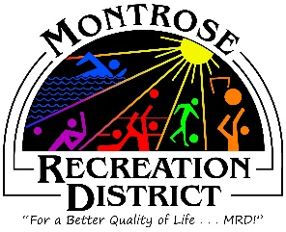

Master Plan Meeting

Growth Committee
Wednesday, April 21, 2021 at 3:30pm
Montrose Community Recreation Center
16350 Woodgate Road
Montrose CO 81401

Attendees: Jim Sheid, Justin Mashburn, Mari Steinbach, Debby Zarkis, Amy Warthen, Christina Files, Jeremy Master

- Discussion of Focus Groups
  - May 12 and 18 have been solidified as the dates of Stakeholders focus groups. It was decided that because of the school schedule, May 12 will be set as the day school related leadership as well as school groups will be invited to participate.
  - The Master Plan Organization Contacts Google Sheet has been shared with all in the Growth Committee. The committee was asked to add contacts as well as add their name if they will be contacting the leaders.
  - Patti Voohris has offered to be translator as needed for Spanish speaking guests.
- Committee reviewed the Virtual Public Meeting Draft and reviewed proposed questions
  - Several questions were revised and a couple questions were added. Debby will pass along these changes to PROS Consulting, Neelay.

Next Meeting
May 7, 1-3pm
Montrose Community Recreation Center
16350 Woodgate Road
Montrose CO 81401

