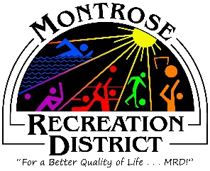

Joint Meeting of the Growth & Finance Committees
Monday, June 12th at 1:30pm
Montrose Community Recreation Center
16350 Woodgate Road
Montrose CO 81401

- Call to Order, Roll Call

- Capital Improvement Plan review

Review the status of the 2023 Capital Improvement Plan and discuss long term priorities funding needs and strategies.
- Review staff action plan for Plant Operating Costs: priorities and placeholders

- Define next Action Steps, Prioritization

- Adjourn

